

Stormwater Credit Application Guide

Acronyms and Definitions
Best Management Practice (BMP) is a term used to describe a type of stormwater quantity and quality control. BMPs refer to a principal control or treatment technique.
Credit Application means a completed application form and all required supporting documents demonstrating on-site stormwater BMPs eligible to receive a Stormwater Fee Credit.
Impervious Area refers to the hard surface area of a property that impedes the absorption of water into the soil, causes reduced quality of runoff water, or causes greater quantities of runoff water relative to the natural surface.
Non-residential means a property that contains industrial, commercial, or institutional uses.
Stormwater means water generated by rain or snow, that falls to the surface of the earth that can soak into the soil, be stored on land surface, evaporate, or contribute to surface runoff. It is also defined in terms of a pollutant carrier as it picks up and transports various pollutants along streets, drains, and storm sewer systems.
Stormwater Management Program means the planning, development, construction, operation, maintenance, renewal and enforcement of by-laws associated with the municipal Stormwater Management System to protect property, infrastructure and the natural environment from erosion, flooding, and to improve water quality.
Stormwater Management System means the City’s infrastructure, or measures, used, controlled, or maintained to manage stormwater flow and drainage systems.

- Introduction

Program Objective
The Stormwater Charge Credit Application Guide is intended to provide general information and assistance associated with the credit application process.

The Stormwater Credit Program is to recognize stormwater best management practices (“BMPs”) and measures implemented on non-residential and multi-residential properties, ultimately to align with the City’s stormwater management goals and objectives per the Stormwater Master Plan. By reducing the amount of stormwater runoff that flows from your property into the City’s storm drainage systems, you can qualify for a credit for up to 50% of your monthly stormwater utility fee.

The City’s stormwater management objectives include:
- Prevent loss of life, minimize property damage and health hazards.
- Protect receiving water courses by minimizing the effect of increased runoff due to new developments and assist in ground water recharge wherever possible.
- Minimize flooding and erosion of lands.
- Minimize sedimentation, siltation, and other forms of pollution on receiving water courses which may result from new developments during all stages of construction.
- Minimize the total capital and operation and unplanned maintenance cost of storm water related work to the drainage basin.
- Apply adaptive management principles for future adjustments to facility functions.

Applicants that receive a Stormwater Credit are making a commitment to abide by the terms and conditions of the approval typically through regular inspection and maintenance of eligible stormwater BMPs.

Policy Consideration & Guideline Principles

There are several items to consider when designing a credit policy. These include:
- Rational Relationship. A rational relationship must exist between the credit and the benefit to the publicly funded system.
- Program Priorities. The credit must further the City's stormwater priorities and objectives.
- Administration. A broader, more complex program increases administrative oversight and costs and therefore the credit program should consider the impacts of administering the program
to ensure it is cost effective.
- Verification and Enforcement. A credit recognizes a benefit to the public system. Ongoing operation and maintenance of a privately owned stormwater management best practice must be verifiable and enforceable.
- Equity versus Complexity. Not all stormwater practices are created equal or are installed for the same reason. Differentiation among practices can make the policy more equitable, but also more complex.
- Shifting Costs. More credit awarded to property owners means more pressure on the storm water rate to other users.
- Public Expectations. Each municipality is unique in terms of public expectations. It is appropriate to consider these expectations provided there is a rational relationship with the Stormwater Management Program.
Based on these considerations, and to ensure a consistent credit policy framework, the following set of guiding principles frame the credit policy:

- Credit Program Administration

Program Eligibility
All non-residential and multi-residential properties that are in good standing with all City by-laws are eligible for the Credit Program, with the exception of any property which is receiving an exemption or subsidy reduction to the Stormwater fee. Single residential properties are not eligible for the credit program.

As the assessment of the Stormwater Charge is parcel-based, Stormwater Charge Credits are to be applied on the same City parcel that is being assessed. Participation in the credit program is by application only.

Credit Duration
Stormwater Charge Credits are effective for a maximum term of five (5) years from the date of approval, subject to compliance with Terms and Conditions, as outlined in Appendix 4, and may be renewed for subsequent five (5) year terms.

Credit Categories
Stormwater Charge Credits are available in each of the three categories below, which align with the City’s Stormwater Management objectives (Table 1). Detailed descriptions and examples of the evaluation criteria for each category are provided in Appendix 2.

Table 1. Stormwater Credit Categories
Category | Description | Evaluation Criteria | Total Credit (50%  Maximum)
Peak Flow Reduction | Manage stormwater runoff rates and reduce the potential and severity of flooding on downstream land and infrastructure. | Aligned with the City’s current development requirements. | Up to 20%
Runoff  Volume Reduction | Reduction of the amount of  stormwater runoff to the City’s stormwater system. | Capture of first 10 mm of  rainfall during a single rainfall event. | Up to 20%
Water  Quality Treatment | Stormwater structures that Remove solids and other  contaminants from stormwater runoff. | Impervious area that is  directed to approved on-site quality control BMPs. | Up to 10%

A maximum credit of 50% can be achieved by a property owner.

Credit-eligible Best Management Practices
Credits for the Peak Flow Reduction, Runoff Volume Reduction and Water Quality Treatment categories are performance-based, rather than prescriptive/presumptive. The property owner must demonstrate that the qualifying structure(s) is fully functional as designed and constructed to meet standards required at time of installation. In addition, the property owner must commit to ongoing maintenance and operation of the BMPs.
A Non-Residential Customer that demonstrates their Site Related Flows are detained on their property or an adjacent property, as part of an overall stormwater management plan, is eligible to receive a credit. The initial credit application (Non-Residential Customer Stormwater Credit Application, Attachment A) must be accompanied by all supporting documents listed under Appendix 1.

The following practices are examples of BMPs that provide measurable reductions in demand on the public system (See Appendix A for photographic examples of BMPs):

    - Infiltration galleries
    - Roof gardens/green roofs
    - Bioretention facilities
    - Dry and wet ponds
    - Permeable pavers/porous pavement
    - Vegetated Filter strips
    - Oil/grit separators
    - Cisterns and/or Greywater Reuse Systems

It is recognized that there are non-engineered activities that can help raise awareness of the owner’s impacts on and responsibility for the Stormwater Management Program. The impacts and efficiency of non-engineered structures are difficult to verify and can result in a significant administrative burden for the City. Based on these considerations, it is recommended that the Credit Program limits credit eligibility to engineered stormwater structures that are, at time of credit application, operating as designed when constructed and implemented. Many of the practices listed above could be eligible for more than one type of credit. For example, the City recognizes that a BMP may provide both peak flow reduction and runoff volume reduction. In such cases, credits may be awarded for both categories. The cumulative maximum credit available to any property is 50%.
Application requires a commitment for continuing maintenance for the award of the credit. Such BMPs will most directly benefit and work in alignment with the City’s Stormwater Management Program.

Performance Criteria
The City’s Stormwater Management Fee Credit Program recommends approval of credits for BMPs that are operational and maintained regardless of purpose for original implementation. Maintaining the BMPs for a stormwater structure is the critical factor in awarding a credit, regardless of the reason for installation.
Eligibility of a BMP will be contingent on proof of function, on-going inspection and
maintenance throughout the credit term. If the approved BMP is not functioning as intended or removed for any reason, the applicable credit(s) may be cancelled.
Note: if the City takes on maintenance responsibilities for certain stormwater structures built as a condition of development, those structures do not qualify for credit.
Although some non-residential and multi-residential properties may ultimately drain to the City’s BMPs, credits are not eligible for any stormwater management facility, funded through the Stormwater Charge Program, located within the municipal right-of-way or within a permanent stormwater easement in favor of the City of Cambridge.

Credit Policy Changes
While credit stability and reliability are important factors when a property owner decides to invest in a stormwater structure, it is also recognized that the City Stormwater Management Program priorities will change over time. The credit policy reserves the City’s right to modify criteria and credit amounts as the Stormwater Management Program evolves and priorities shift.

- Application Process

Types of Application
The Credit Program is implemented through an application and approval process that involves initial documentation, certification that the necessary information is complete, City review of the application, and approval or denial of the credit.

There are three types of Credit Applications:
    - New Credit Application – (1) applying for a credit on a property with an existing BMP or eligible activities for the first time; or (2) applying subsequent to the cancellation of an approved credit.

    - Credit Update Application – (1) when an approved credit needs to be updated to reflect a Material Change1 made to the property that could affect the distribution or validity of approved credits; or (2) updating approved Operation and Maintenance Plan; or (3) updating approved credit application with enhancements applied.

    - Credit Renewal Application – when an approved credit is about to expire. Credit Renewal Applications must be submitted to the City no less than three (3) months prior to the expiration date of the credit.

Supporting Documentation
For all credit applications, supporting documentation is required which demonstrates how the BMPs meet the criteria set out in this Credit Program Policy. Supporting documentation must be prepared by a Professional Engineer registered in the Province of Ontario and qualified in municipal engineering and stormwater management.
The report, including relevant supporting information, must meet the City of Cambridge’s development requirements (or generally accepted professional practices where City of Cambridge requirements currently do not exist), for development applications seeking approvals for storm drainage and stormwater management. Full supporting documentation requirements are outlined in Appendix 1.

The Applicant is solely responsible for the costs incurred in the preparation of the required documentation and/or the submission of the credit application.

Application Process
The City accepts completed Credit Applications online or by mail and/or supporting documentation in either hard-copy or digital (PDF) format. There is no application fee.
Please note that the submission of a Credit Application may result in a reassessment of the Stormwater Charge for the property.
The following are helpful tips when submitting a complete Credit Application:

- Visit the City of Cambridge Billing Webpage https://www.cambridge.ca/en/your-city/Billing.aspx
- Click on the Stormwater Fee Credit Program section.
- Select the red Apply Online button.
- Access the “My Water” Portal
- You’ll be redirected to the My Water portal.
- If you don’t have an account:
  - Click Register
  - Create a new account using your email and property details.
- Log In to My Water
- Enter your credentials to log in.
- Once inside, go to the Self-Serve dashboard.
- Use the Side Menu
- On the right-hand side, click Storm Water.
- Start a New Application
- In the top-right corner, click New Application.
- Fill out the required fields for the Storm Water Fee Credit.
- Submit Your Application
- Review your information.
- Submit the application.
You will receive a confirmation email and reference number.

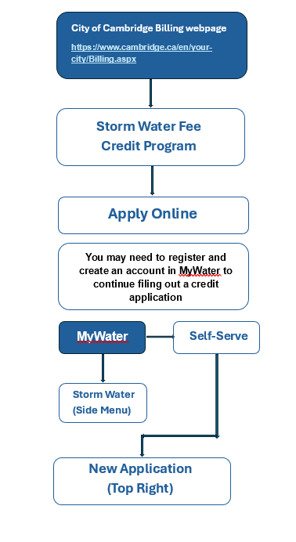

Helpful Tips when applying online:

- Applicant Information
  - Registered Owner –the Applicant is the owner of the property.
  - Authorized Agent of Owner –the Applicant is not an owner of the property but has permission to act on behalf of all the owners of the property.
- Contact Information
  - If the Applicant is the authorized agent of the owner, the contact information of the registered owner or property management company must be provided as well.
- Property ID(s) – this number is created for every parcel of land in Cambridge by the City’s GIS team.
- Previous Permit Number – the Applicant is required to provide previous Credit Application number when submitting a Credit Update or Renewal Application.
- Attachments – the Applicant is required to upload all required supporting documents to complete the submission (refer to Appendix 1).

Review Timelines
Review of a Credit Application Process:
    - Assessment for application completeness; and
    - Technical review of application.
    - Final Determination
    - Appeal Process

Applicants will receive an auto-email with an application number to confirm the successful submission online.

3.4.1 Completeness Review
The Stormwater Water Resource Engineer will conduct an initial screening to ensure application eligibility. Applicants may be requested to provide additional information. If an Applicant fails to provide the necessary information within thirty (30) calendar days, the application will be rejected. The City may also conduct an initial site inspection if desired, as described in Section 5.1.

A Credit Application is deemed complete when the Applicant has filled out all appropriate sections of the application form and submitted the relevant reports and documentation which support how the stormwater BMPs, operations and activities satisfy the credit evaluation criteria.

3.4.2 Technical Review
The technical review of an application is expected to be completed within thirty (30) calendar days of a complete submission. Credit approval may be awarded, or additional technical information or clarification may be requested by staff during this time. In the event the technical review results in a request for additional information or clarification, a new thirty (30) calendar day period will be re-set upon receipt of all information requested.

3.4.3 Final Determination
Upon review of the application and a site inspection, the City will notify the applicant of the final determination of the technical review team. If successful, the applicant will receive the applicable credit(s).

3.4.4 Appeal Process
If the applicant is unsuccessful in their application for a credit, or their existing credit is reduced or cancelled, the applicant may appeal the decision by contacting the Water Resources Engineer in writing. A formal review process will be initiated.

Effective Date and Duration of Approved Credit
Once the City has approved the credit application, the effective date of the credit will be upon the next complete billing cycle. Once applied, the credit will remain in place for a period of five (5) years. Credit update applications will not extend the period of the existing credit.

Stormwater Charges Billed while Credit Application is Under Review
A pending credit application does not constitute a valid reason for non-payment of the currently- assessed Stormwater Charge. Any stormwater charge bill that is received during the credit application review process must be paid in full.

- Functional Verification and Maintenance Commitment of the Credit Approval
Stormwater structure verification is a key component to granting a credit and involves both initial verification that a structure is operating as designed, as well as ongoing verification through regular inspections. This is conducted by a professional engineer, or another qualified person as approved by the City. Failure to comply with the terms and conditions may result in the suspension or cancellation of approved credits. Refer to Appendix 4: Terms and Conditions for Credit Award

Operation and Maintenance
Credit holders must comply with the approved Operation and Maintenance Plan detailed in the Credit Application or other supporting documentation, and/or meet the City’s minimum inspection and maintenance requirement of an annual inspection. All inspection, maintenance logs and photos must be retained on file and be made available upon request throughout the entire term of the credit.

Inspection during Credit Period
The City of Cambridge is authorized to conduct periodic random inspection of approved credits. Credit holders must respond to the inspection request, confirm site inspection schedule with City staff and submit required documentation within the required time frame (see section 5.2 for further details).

Credit Renewal
Credits are effective for a maximum term of five (5) years from the date of approval. Credit holders are required to submit a Credit Renewal Application at least three (3) months prior to the expiry date should they wish to seek a renewal of the existing stormwater credits without experiencing a gap in the credit approval.

5. Site Inspections

Site Visit during Application Review
As part of any credit application review process, the Stormwater Water Resource Engineer or designate may contact the Applicant with a requested date to conduct a site visit to verify that any constructed BMPs or activities are in conformance with the documentation provided and that these measures are operating in accordance with documented performance criteria. The results of this inspection will be taken into consideration as part of the application review.

If the Applicant fails to respond to the Stormwater Water Resource Engineer or designate by telephone, email or in writing to coordinate a site visit date within thirty (30) calendar days, the credit application will be cancelled. The inspection must proceed within sixty (60) calendar days of the initial request. If the Applicant is unable to provide a date to facilitate the inspection within this time frame, the credit application will be cancelled.

Inspections during Credit Term
Credit holders have the responsibility to regularly (Annually) inspect, maintain and repair BMPs receiving credit to ensure that it is functioning as designed, and maintained as agreed to in the terms and conditions, as outlined in Appendix 4 of this document.

In addition, the City reserves the right per Storm water Fees and Charges By-Law 24-075, as amended, to conduct audit inspections and may, at any reasonable time, enter and inspect any property with credits. The intent of the audit inspections is to assess whether the stormwater BMPs are being inspected/maintained as stipulated in the submitted Operation and Maintenance Plan or satisfying the City’s minimum program requirement (annual inspection), that the conditions on-site are consistent with the documentation provided in the most recent credit application, and that the BMPs are operating in accordance with performance criteria as documented in applicable documents. Audit inspections will typically involve on-site assessments, self-assessments, informal interviews, review of inspection and maintenance logs, photos, and additional information as required. As a result of an audit inspection, credits may be suspended, reduced or cancelled.

Credit holders are required to acknowledge receipt of the audit request within thirty (30) calendar days. The inspection requirements, including on site, self-inspections and submission of all required documents are to be completed within sixty (60) calendar days from the date of the audit request.
Delays or failure in satisfying the audit requirements may result in a cancellation of credit.

The inspection will result in a grading of either “passed,” “suspended” or “failed”. Sites that are “suspended” will be given a sixty (60) calendar day period to take remedial action to bring their property up to a passing standard. Failure to take required action within sixty (60) calendar days may result in a cancellation of credit.

7. Credit Renewal Application
All credits are valid for five (5) years. Credit holders are advised to submit a Credit Renewal Application at least three (3) months prior to the expiration date should they wish to renew their existing stormwater credits without experiencing a gap in receiving their credit. Applications received after the threshold date may not be processed and approved in time before the previous credit expires. In such circumstances, the account holder will not receive credit towards the stormwater charge during the period in which the previously approved credit has expired, and the renewal application has not been approved. An approved credit renewal shall be effective upon the expiration date of the previous credit, or as otherwise determined by the Stormwater Water Resource Engineer.

In addition, credit holders wishing to renew their credit shall provide evidence that acceptable operation and maintenance practices have taken place and that the BMPs are in a state of good repair. Details on supporting documentation requirements for Credit Renewal Applications are provided in Appendix A1.3.

Appendix 1: Supporting Documentation for Applications

A1.1 New Credit Applications
To apply for a new credit or to update an existing approved credit for new and/or existing BMPs, the Applicant must provide a completed application form and the information listed below, as applicable, to the Stormwater Water Resource Engineer.

A1.1.1 Categories: Peak Flow Reduction, Water Quality Treatment, and/or Runoff Volume Reduction

Engineer’s Certification of Operation
This certification must be in the form of a letter addressed to the Stormwater Water Resource Engineer, signed and stamped by a qualified Professional Engineer. It must include the following:
  - Certification that all BMPs have been constructed in accordance with the submitted drawings and that they are operational; and
  - Confirmation of the date(s) that all BMPs were implemented into service.

A template for the certification letter has been provided in A1.4.

- Stormwater Management Report certified by a qualified Professional Engineer and accompanied by the above letter, signed by the author of the report, which allows the City of Cambridge to make reliance on the findings and conclusions presented in the report. This report is expected to be generally consistent with current City of Cambridge development requirements for on-site stormwater management reports and must include details outlining the credit percentage applied for and all calculations how the BMPs achieve the credit requirements, and other relevant information.

  - Site plan and/or related engineering drawings and details should conform to the City’s development requirements with the following information to be shown as a minimum:

    - Location
    - Property boundaries
    - Easements
    - Topographic details
    - Locations and outlines of all structures, including buildings, parking, driveways and other impervious areas
    - Drainage areas, including internal drainage patterns and areas, as well as external drainage areas draining to the site
    - Stormwater BMP and/or related drainage details

- Hydrologic and hydraulic calculations and/or modelling results to support Peak Flow Reduction, Water Quality Treatment and/or Runoff Volume Reduction credit categories. Operation and Maintenance Plan
  - Proposed inspection and maintenance plan, including record keeping, logging, and photos (refer to A1.5 Inspection and Maintenance Log Template);
  - Details on the procedures to be performed; and
  - Inspection and maintenance records must be kept on file by the Applicant or site owner/operator for the duration of the approved credit and be made available to City staff upon request.

A1.2 Credit Renewal Applications

A1.2.1 Categories: Peak Flow Reduction, Water Quality Treatment, and/or Runoff Volume Reduction
To renew a previously approved credit, the Applicant must submit a completed application form and the information listed below, as applicable, to the Stormwater Water Resource Engineer.

- A report certified by a qualified Professional Engineer providing the following information:
  - Confirmation that the performance of all BMPs remains consistent with the previously approved credit application
  - Confirmation that all BMPs are in a state of good repair
  - Agreement is still valid (for Credit Sharing Application only).

- Inspection and maintenance logs, including:
  - Dates of inspection and maintenance activities
  - Annual photos of BMP at to accompany log
  - If maintenance was done on BMP, post maintenance photos to be included in addition to annual photos
  - Names, titles, and qualifications of personnel conducting the inspections and/or maintenance
  - Condition of each BMP, including its functional components
  - Any other item that could affect the proper function of the BMP
  - Description of maintenance performed
  - Updates to the operation and maintenance plan, if needed

A template of inspection and maintenance log is provided in A1.5.

A1.3 Engineering Certification Template
Date:

To: City of Cambridge
50 Dickson Street
PO Box 669
Cambridge, Ontario
N1R 5W8

Attn: Stormwater Water Resource Engineer, Environmental Services

RE: BMP CERTIFICATION
(Credit Application Number) (Municipal Address, Property ID) (Description of BMP)

(Company name) has served as the engineering consultant for the certification of the (description of BMP) at the above noted address. This letter will confirm that I/We have inspected the (BMP) on the above noted lands and do hereby certify that all systems have been designed and constructed in accordance with (Drawing No. , dated and Functional Servicing Report, dated ).

This letter confirms that I/we have inspected _____________________________[stormwater structure]
on the above noted property and do hereby certify that all systems have been designed and constructed in accordance with ____________________ [drawing number], dated _______________.

I/we further certify that all structure components are completed and operational in accordance with sound engineering practices and principles and are based on guidance from ___________________________ [applicable design and/or standards manual].

Further, I/we hereby confirm that the _____________________________[structure type] has been implemented into service and is operational as of _______________ [date].

Should you have any questions or concerns regarding this letter, please do not hesitate to contact me/this office at ______________________________ [phone number and email].

Sincerely,

___________________________________
Company Name

___________________________________
Signature

___________________________________
Printed Name Professional Engineer Stamp
A1.4 Inspection and Maintenance Log Template [NEW]

Stormwater Credit Inspection and Maintenance Log

This maintenance log template will be used by the applicant/applicant’s engineer to verify
that the stormwater management structure has been properly maintained and is operating
in accordance with the operations and maintenance plan set out in the approved credit application. This form is to be completed annually and submitted to the City as part of a
renewal application. All credited BMPs must be inspected. The log must be made available
for submission to City staff upon request.

Site Address:
Credit ID: ______________________________________________________________
Site Rep. Name: Phone Number: Email Address:

Example of BMP  Inspected | Inspector Name | Date of Inspection | Confirmation that Equipment is Functioning  Properly | Deficiencies (if applicable) | Actions Taken (including dates) | Date of Resolution | Confirmation that Equipment is Functioning  Properly
Roof drains
Parapet
scuppers
Orifice plate
Oil and grease treatment
devices
Permeable pavement
Infiltration galleries
Etc.

Include images of the BMP at time of inspection with your log. If maintenance activities are performed, include an after photo of the BMP

Appendix 2: Credit Evaluation Criteria

A2.1 Peak Flow Reduction (up to 20%)

Evaluation criteria
A site that meets the City’s current stormwater management design criteria (controlling the 100-year design storm post-development flow rate to the pre- development flow rate) or that meets the applicable design standard at the time the BMP was originally approved and constructed would be eligible for the full 20% value of the peak flow reduction credit.

The amount of credit, up to 20%, is based on reducing the allowable peak flow for the entire site by between 5% and 20% during a 100-year storm event. The site is defined as the geographic area required to meet the City’s stormwater management requirements at the time of development/expansion. Credit is based on the reduction amount, with 5% credit for a reduction of 5% up to 20% credit for a reduction of 20%. Calculations apply to all impervious areas on the site.

Evaluation metric
Flow reductions that fall between the above limits for a credit will be assigned to an appropriate credit at the
discretion of City staff through the technical review process.

- 20% credit – full reduction of the post-development flows to the pre- development flow rate
- 15% credit – 75% reduction of the post-development flows to the pre- development flow rate
- 10% credit - 50% reduction of the post-development flows to the pre- development flow rate
- 5% credit – 25% reduction of the post-development flows to the pre- development flow rate

Self-certification shall be provided by way of a report certified by a Professional Engineer that includes supporting calculations.

Flow reductions that fall between the above limits for a credit will be assigned to an appropriate credit at the discretion of City staff through the technical review process.

The reduction would be calculated as:
(Uncontrolled post-development flow minus controlled post-development flow) divided by (uncontrolled post-development flow minus pre- development flow)
For the purposes of calculation, the pre-development flow is the flow included in an approved Stormwater Management Report or the flow calculated using a runoff coefficient of 0.25.

Example 1A: Categories: Peak Flow Reduction
The uncontrolled 100-year post-development flows from a site are 70 L/s. The pre-development flows are 20 L/s. A property owner has designed and constructed a bioretention facility that controls the post-development flows leaving the site to 58 L/s.

(70 L/s - 58 L/s) / (70L/s -20 L/s) = 12/50 = 25%
Under the peak reduction credit, the owner would be eligible for a credit of 5% as there is a 25% reduction of peak flows,

A2.2 Runoff Volume Reduction (up to 20%)

Evaluation criteria
A site that meets runoff volume controls as required through a Subwatershed Study or an area that includes the specific site would be eligible for the full 20% value of the runoff volume credit.

For sites that do not have requirements for runoff volume controls but have constructed BMPs that provide voluntary controls and/or have retrofitted existing BMPs to include runoff volume controls, credits would be available based on the equivalent volume of runoff controlled/retained on site
  - 20% credit – runoff volume controls as per the requirements of a Subwatershed Study or the control of the equivalent volume of 10 mm of runoff from all impervious surfaces on the site
  - 15% credit – runoff volume control of the equivalent volume of 7.5 mm of runoff from all impervious surfaces on the site
  - 10% credit - runoff volume control of the equivalent volume of 5 mm of runoff from all impervious surfaces on the site.
Sites that control/retain runoff from only some impervious areas (i.e. the rooftop) may be eligible for credit if the equivalent volume from the limited areas meets one of the above criteria when compared against the volumes for the entire site.

Points of clarification
- “capture” means for on-site retention managed by way of infiltration, evapotranspiration, re- use or filtration.
- Only applies to rainfall landing on the impervious area(s) of the property; and
- “single rainfall event” means a period of rainfall activity defined by preceding and following periods of at least 24 hours without measurable rainfall.
Example 1:
A site is located within the boundaries of the ABC Subwatershed, and the corresponding Subwatershed study identifies that 9mm of runoff is to be controlled/retained on site. The site design includes a bioretention facility which will retain and infiltrate the equivalent volume from 9 mm of runoff from the rooftop and parking areas of a site. Under the runoff volume credit, the owner would be eligible for a credit of 20% as there is control/retention of the required volumes as identified in the Subwatershed study.
Example 2:
A 10,000m2 site consists of 2,500m2 of rooftop and 4,500m2 of parking/impervious surfaces with the remainder of the site being landscaped or grass areas.
An infiltration gallery has been designed and constructed to retain and infiltrate the equivalent volume from 15 mm of runoff from the rooftop area only.
15mm x 2,500 m2 of rooftop = 38 m3 of runoff
By comparison, 5 mm of rainfall x 7000 m2 of total impervious area = 35 m3 of runoff.
Under the runoff volume credit, the owner would be eligible for a credit of 10% as the controlled/retained volume from the rooftop only is comparable to the equivalent volume of 5 mm of runoff across the entire site.

A2.3 Water Quality Treatment (up to 10%)

Evaluation criteria
Water quality credits are available to properties that provide onsite quality treatment regardless of the presence of a downstream Municipal stormwater management facility. A sliding scale based on water quality treatment levels is applied.

Eligible water quality treatment facilities typically include tanks, reservoirs, ponds, wetlands, or lagoons. Additionally, the City will also award credits for oil/grit separators (OGS), or other BMP/LID facilities that provide basic pre-treatment. Pre-treatment devices include any structural measure that is specifically designed for temperature control, nutrient removal, or sediment settling upstream of any conveyance or detention storage asset as described above in section 2.4. and Consistent with Provincial criteria for enhanced treatment - note that the current reference for Provincial criteria for enhanced treatment is the Stormwater Management Planning and Design Manual, March 2003, Ontario Ministry of the Environment.

Note: Water quality treatment below 60% TSS removal, or “Basic” level treatment, will not be eligible for a credit.

Appendix 3: Examples of Stormwater Management BMPs
As identified in Section 5, examples of Stormwater Management Best Management Practices (BMPs) eligible for credit consideration include, but are not limited to:
- Bioretention facilities
- Constructed wetlands
- Green roofs
- Dry and wet ponds
- Permeable pavers/porous pavement
- Vegetated Filter strips
- Oil/grit separators
- Cisterns and/or Greywater Reuse Systems
The design and ultimate purpose of stormwater management facilities vary along with the standards under which the BMP was built. The following photographs provide examples of each of these primary categories of BMPs.

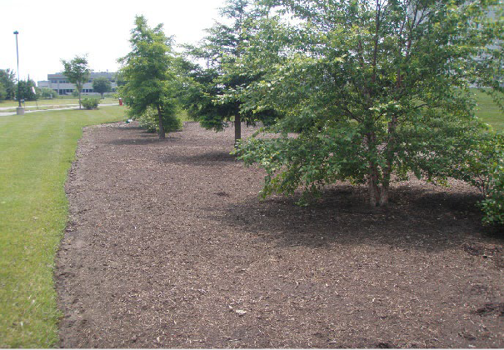 | 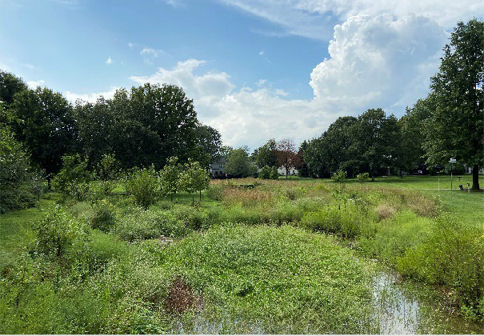
Bioretention Facility | Constructed Wetland
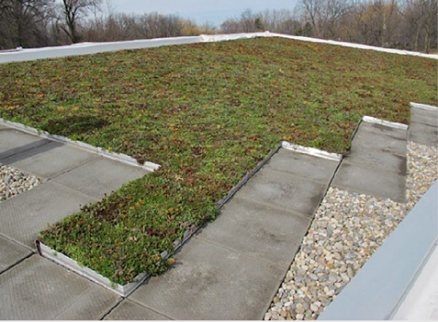 | 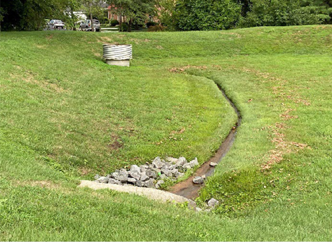
Green Roofs | Extended Detention Dry Pond
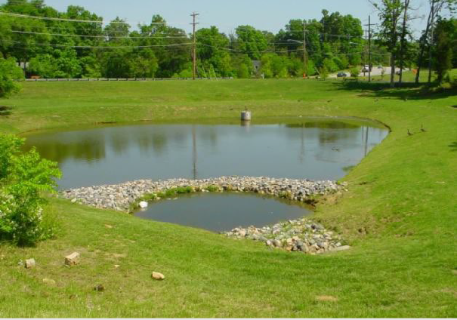 | 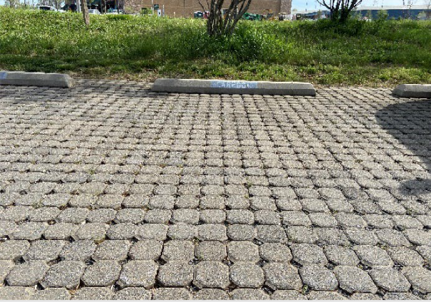
Wet Pond | Permeable Pavers
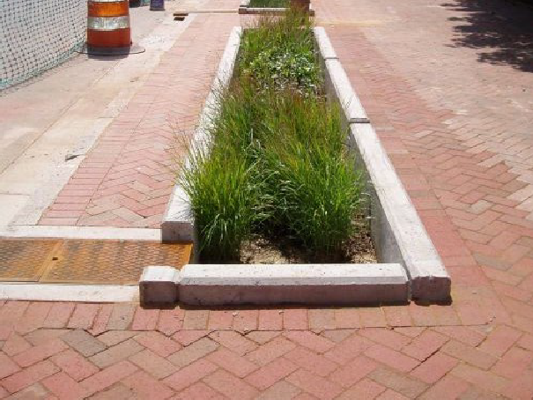 | 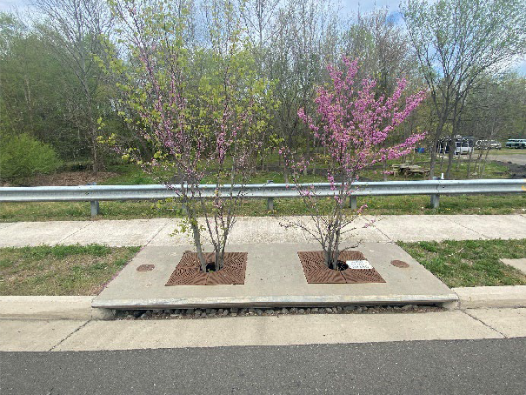
Urban Filter Strip | Tree Box Filter
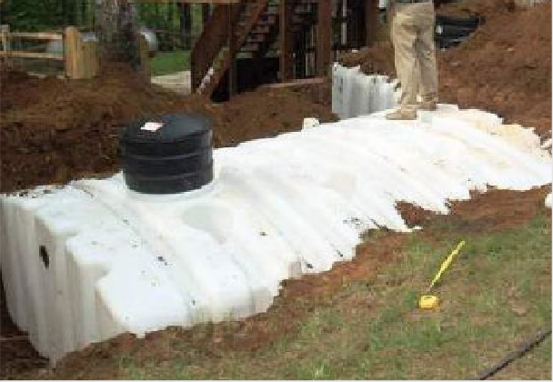 | 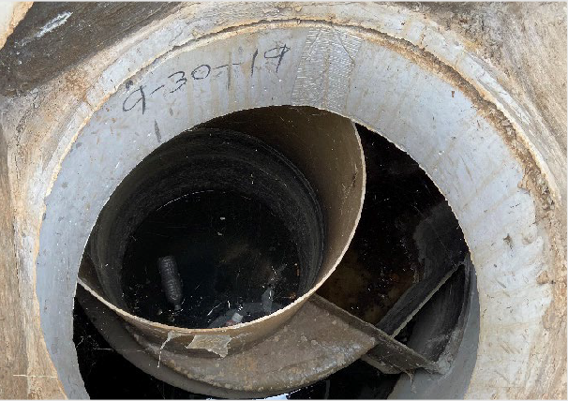
Oil/Grit Separator | Cistern/Greywater

Appendix 4: Terms and Conditions for Credit Award

Terms & Conditions for Stormwater Fee Credit Application
Terms & Conditions for Award of Credits In consideration of applying for, and receiving credits toward the assessed stormwater charge from, the City of Cambridge, the Applicant can demonstrate that the property owned by the Applicant (the “Property”) contains impervious areas that are directed to approved, or in accordance with, stormwater quantity and/or quality best management practices (“BMP”). the Applicant acknowledges and agrees to the following:

- Responsibility for BMP Works and Measures
The Applicant is solely responsible for coordinating and covering all costs related to the installation, construction, operation, maintenance, and repair of any works. Any BMP must comply with all applicable municipal, provincial and federal standards and guidelines; The Owner must inform subsequent owners of maintenance obligations upon property sale.

  - Status of BMP Performance
As long as the BMP functions as approved, verified by self-certification and City inspections, the credit will apply to the stormwater portion of the utility bill. If the BMP fails or is terminated, the credit will be cancelled, and the rate will revert to the baseline. The Applicant must reimburse the City for the credit received since the last inspection. After cancellation, reapplication for a credit is prohibited for 12 months and only after rectifying the deficiency as determined by the City.

  - Site Inspections and Document Audits
The City reserves the right to enter and inspect any property in this program at any reasonable time to verify eligibility. The City may request further documentation or reject, suspend, reduce, or cancel credits if inspections or records do not meet performance criteria. Failure to provide access as required will result in credit application rejection or cancellation.

  - Liability
The City’s decision to award a credit or pass an inspection does not imply liability, responsibility, or guarantee of workmanship quality or defect-free performance. The Applicant must indemnify and hold the City and its representatives harmless against all liabilities, losses, costs, claims, damages, and expenses, including third-party bodily injury, death, personal injury, and property damage, arising from participation in this Program or the implementation of the works.

  - Maintenance Requirements
Approved stormwater management practices must meet performance criteria as documented in the Stormwater Charge credit application, update, renewal, or supporting documentation, such as the “Operation and Maintenance Plan” and terms of approval.

  - Duration of Credit
Stormwater Charge credits are valid for the period of 5 years, or as specified at approval. Credits will expire if not renewed at least three months before the expiration date.

  - Suspension of Credit
The City may suspend, reduce, or cancel a Stormwater Charge credit if the application contains any material misstatement or the stormwater management practice is in disrepair, the Applicant must reimburse the City for the entire credit amount received since the last approval or inspection. The City can collect this credit by any legal means. If cancelled, the Applicant cannot reapply for at least 12 months.

  - Update Responsibilities
A credit update application must be submitted to the City. The City shall have full and absolute discretion to adjust (increase or decrease) the current credit amount.

  - Renewal Criteria
A credit renewal application must be submitted to the City. The City shall have full and absolute discretion to adjust (increase or decrease) the current credit amount.

  - Review Timelines
An initial assessment will be conducted for application completeness. The Applicant may be requested to provide additional information. Complete applications will be registered, and the Applicant will be notified. The technical review of an application is expected to be completed within thirty (30) calendar days after registration. Credit approval may be awarded or rejected or additional information or clarification on matters from the Applicant may be requested during this time. In the event the review results in a request for additional information or clarification on matters from the Applicant, a new thirty (30)-day period will be re-set upon receipt of all information.

  - Program
Stormwater fee Credits do not apply for new development or redevelopment projects; The City reserves the right to cancel, suspend or alter the program at any time.

  - Payment During Application Review
A pending credit request application shall not constitute a valid reason for non-payment of the currently assessed stormwater charge. Any stormwater charge bill that is received during the credit application review process must be paid in full.

  - Credit payment
Public or private properties will not qualify for credits unless the condition or activity directly contributes to reducing the City’s stormwater management costs, as determined by the Director of Environmental Service. Credits are only granted to the registered property owner.

