Study Description A Pedestrian Level Wind Study (Wind Study) is conducted to assess and, where necessary, mitigate the impact of a development on pedestrian level wind conditions. The objective is to ensure pedestrian comfort and safety is maintained as the City of Cambridge continues to grow and develop. The Terms of Reference provides technical guidance for standardization of Wind Study methodology, triggers, along with wind comfort and safety criteria, result presentation, and wind mitigation.
Purpose The purpose of this Terms of Reference (“TOR”) is to establish clear expectations and requirements for the preparation of Wind Studies submitted to the City of Cambridge. Compliance with these guidelines will help to expedite review times and mitigate the need for further revisions and submissions. Failure to satisfy the requirements set out in this TOR may result in an application being deemed incomplete. If an application is deemed incomplete it will be returned to the applicant to satisfy the necessary submission requirements.
Definitions Boundary-Layer Wind Tunnel – A test section that can simulate the wind flow characteristics of the built and natural environment and is able to predict both mean and gust wind speeds.
Computational Fluid Dynamics (CFD) – The use of computer modelling and simulations to mathematically solve for wind speeds and directions for a defined domain.
Configuration – The layout and design of scale-model buildings and structures to be evaluated.
Exceedance – To go beyond (or exceed) a defined threshold.
Qualitative Study – A non-numerical desktop assessment based on engineering judgement and knowledge of wind flows around buildings. This knowledge and experience, together with literature, allow for a reliable, consistent, and efficient estimation of pedestrian wind conditions without a quantitative study.
Quantitative Study – A numerical assessment based on CFD simulations and wind-tunnel measurements. This includes a computer or physical model of the study site, immediate surroundings, and topography (if required). The simulated wind flow information is then combined with local wind records to predict wind speeds for the areas of interest.
When is it Required? A Wind Study may be required for the following Planning Act applications:
- Official Plan Amendment
- Zoning By-law Amendment
- Secondary and Community Plan
- District Plan
- Draft plan of Subdivision
- Draft plan of Condominium
- Consent Application
- Minor Variance
- Site Plan Control
- Other planning applications, as determined by the City.
The need for a Wind Study as part of a complete application will be identified as part of the pre-application consultation review. In the instance where a planning application being advanced does not have a mandatory pre-application consultation process (e.g., Committee of Adjustment applications), the applicant is encouraged to contact the City’s Planning Division to discuss the nature of the proposal and to determine if a Wind Study is required.
The information presented below should be considered when a proposed development application is received to ensure the correct Wind Study is to be conducted.
Table 1: Building Height Triggers for a Wind Study
Building Height | Wind Study Requirements
15 m to <25 m | Zone Change Application – A qualitative Desktop estimation of pedestrian winds is required to identify any building design issues and to provide conceptual solutions for wind control, where needed.  Site Plan Application – An update to the qualitative study will be required if changes have been made to the building or site design that may impact the findings of such study.
25 m to <40 m | Zone Change Application – A quantitative study using Computational Fluid Dynamics (CFD) is required.  Site Plan Application – Depending on the findings and recommendations from the Wind Study for the Zone Change Application, the additional wind study may range from a qualitative letter (to confirm the compliance and no significant design changes) to a more quantitative wind-tunnel study (to assess the potential wind conditions and, if needed, to develop and confirm the effectiveness of wind mitigation measures). Otherwise, another run of CFD study will be sufficient. However, this should be confirmed with the City of Cambridge.
≥40 m | Zone Change Application – A quantitative study using physical scale modelling in a boundary-layer wind tunnel is required to assess the potential wind conditions and, if needed, to develop and confirm the effectiveness of wind mitigation measures.  Site Plan Application – An update to the quantitative study will only be required if significant changes have been made to the design at this stage, at the City’s discretion.
Additional Triggers
In addition to the height triggers, a more detailed Wind Study (i.e., a higher level of study from the table above is required if:
- The proposed development is composed of two or more buildings; or
- The development is located along the west side of Waterloo that is exposed to westerly winds.
Qualified Persons A Wind Study shall be prepared by qualified and competent Professional Engineer in good standing with adequate experience in pedestrian wind evaluation. The report must identify and be signed and stamped by the author(s) and, where prepared under the direction of a qualified professional, stamped and signed by the reviewer of the report. The qualified professional that has signed the report shall take professional responsibility for its contents and the accuracy of the information contained therein.
Applicable Legislation The authority to require or request information or material to evaluate and make a decision on proposed planning applications is provided by the Ontario Planning Act, the Provincial Policy Statement, and City of Cambridge Official Plan Section 10.14 (“Complete Applications”).
This Terms of Reference document is to be applied in conjunction with all applicable regulations, by-laws, and guidelines, including the City of Cambridge’s Urban Design Manual and Comprehensive Engineering and Landscape Manual.
Study Requirements This TOR document sets out the minimum requirements that must be included in all studies. More specific scoping of the Wind Study may be identified by appropriate staff during the pre-application consultation process.
Meteorological Requirements:
Long-term (e.g., last 30 years) hourly data from the Region of Waterloo International Airport should be used as a reference for any qualitative and quantitative wind assessment. The data should be categorized into two seasons: summer (defined as May through October) and winter (November through April), for the potential differences in pedestrian outdoor behaviours to be captured during these two periods.
Technical Requirements:
A qualitative assessment of wind conditions is largely based on wind consultants’ knowledge of wind flows around buildings and experience with CFD simulations and wind tunnel tests on similar building projects. Quantitative wind assessments that use CFD and/or wind tunnel testing to predict wind conditions for all wind directions also require consultants’ knowledge and experience.
A quantitative wind tunnel study should be conducted in a boundary-layer wind tunnel where wind and turbulence profiles are adequately simulated for a full 36 wind directions. Both mean and gust wind speeds should be measured at 1.5 m above local grade for the existing surroundings with and without the proposed development. In addition, the construction of the proposed development shall be no smaller than 1:500 and at a minimum will include all buildings within a radius of 350 m of the site.
All types of studies must assess wind comfort levels in pedestrian areas on the proposed site and adjacent land. Of particular importance are public spaces such as parks, public courtyards, building entrances, sidewalks, bike lanes and multi-use paths. Privately Owned Public Spaces (POPS) should also be evaluated. Private outdoor spaces within the development, such as private amenity terraces and balconies, are not required to be assessed for wind comfort; however, ensuring that the users of the private spaces (especially those at grade) will not be exposed to dangerous wind conditions is recommended.
In addition to the above, a Wind Study should consider the following:
- Configurations – At minimum, an existing site condition assessment along with a proposed development assessment should be conducted. In addition, should the development be phased, or when there is a significant development or demolition planned for the surrounding area in the future additional site configurations should be considered.
- Assessment locations – These locations should cover key pedestrian areas on the development site and in the surrounding areas.
- Landscaping – The effect of existing and proposed landscaping may not be considered as it is common practice to establish baseline conditions without landscaping details.
- Mitigation strategies – When considering mitigation strategies, the effect of landscaping on wind conditions may be considered. If needed, mitigation configuration(s) should also be included to demonstrate the effectiveness of the mitigation measures.
Pedestrian Wind Study Criteria:
The predicted wind speeds and frequencies should be compared to the following wind comfort and safety criteria shown below in Table 2. Wind comfort may be affected by both mean and gust speeds and their combined effect should be quantified as a Gust Equivalent Mean (GEM), while only gust speeds are to be considered in the wind safety criterion.
Table 2: Pedestrian Wind Comfort and Safety Criteria
Comfort Category | GEM Speed (km/h)^{1,2} | Description
Sitting | < 10 | Calm or light breezes desired for outdoor restaurants and seating areas where one can read a paper without having it blown away.
Standing | < 15 | Gentle breezes suitable for main building entrances, bus stops, plazas, and other places where pedestrians may linger.
Walking | < 20 | Relatively high speeds that can be tolerated if one’s objective is to walk, run or cycle without lingering.
Uncomfortable | ≥ 20 | Strong winds of this magnitude are considered a nuisance for all pedestrian activities, and wind mitigation is typically recommended.
Safety Criterion | Gust Speed (km/h) ³ | Description
Exceeded | > 90 | Excessive gust speeds that can adversely affect a pedestrian's balance and footing. Wind mitigation is required.

Notes:
- GEM speeds are equal to the gust speed divided by 1.85, or the mean speed (whichever is larger) and gust speed can be simulated or measured directly or estimated by mean speed + 3 x rms speed.
- GEM speeds listed above are based on a seasonal exceedance of 20% of the time between 6:00 and 0:00. Nightly hours between 0:00 and 6:00 are excluded from the wind analysis for comfort since limited usage of outdoor spaces is anticipated; and,
- Based on an annual exceedance of 9 hours or 0.1% of the time for 24 hours a day.
Reporting Requirements Upon the completion of a Wind Study, a technical report shall be prepared to describe wind conditions at key pedestrian areas on and around the development.
- For all test configurations, wind comfort conditions must be described for summer and winter seasons, and wind safety conditions on an annual basis.
- The results should be presented in tabular and graphic forms for all test configurations.
- Provide a conclusion or summary to indicate if and the frequency that comfort and/or safety wind conditions may be exceeded.
- Provide recommendations for mitigation where wind safety conditions are exceeded and to bring wind conditions to appropriate levels.
Wind Control
Mitigation Strategies A description of three levels of wind control strategies, moving from large-scale to small-scale features, is provided in the following section.
Building Massing
The most effective wind control measures involve adjustments to the building early in the design process and relate to the location, orientation, height, and massing of buildings. Responsive to the local wind climate, these large-scale modifications can be assigned by features like tower setbacks, large podiums, tower shapes, corner articulations, colonnades/arcades, etc.
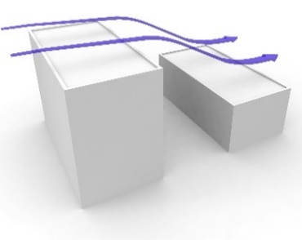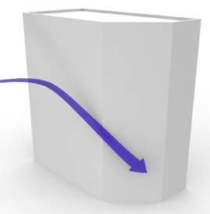
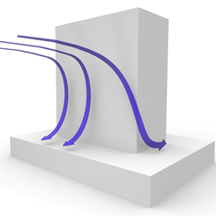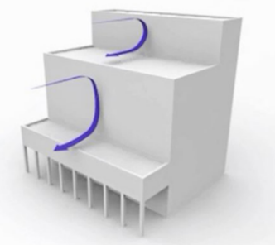
Image 1: Examples of Building Massing Details for Wind Control, Provided by RWDI.
Architectural Details
Features such as façade articulations, canopies, covered walkways and recessed entrances are effective solutions for localized wind mitigation. Recessed walls create areas that will be protected from ambient wind activity. If entrances are in such recessed areas, it also creates a waiting area for patrons using the entrance, as well as a transition zone for patrons exiting to get acclimatized to the ambient conditions. Covered walkways, similarly, provide a protected area for pedestrians at the base of tall towers that are prone to downwashing impacts.

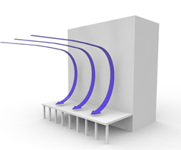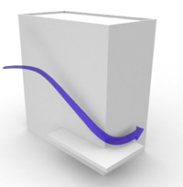

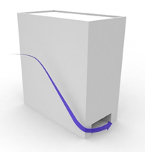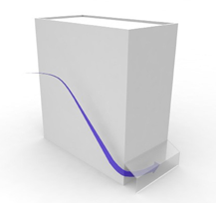
Image 2: Examples of Architectural details for Wind Control, Provided by RWDI.
Localized Accessory Elements
Smaller-scale measures such as wind screens, trellises, street art, landscaping and other localized features (Image 3) can be considered at an advanced design stage, after all possible larger-scale measures have been considered and implemented, for area-specific wind speed reductions and refinements. The impact of these features is typically limited to a small area immediately surrounding them. Wind screens may be placed on both sides of entrances, on private sidewalks and other amenity spaces on private lands to create localized low wind areas. It is recommended that wind screens implemented should be at least 2 m tall and approximately 30% open/porous for good wind control efficacy.
Landscaping elements, especially coniferous and marcescent species, are commonly used to improve wind conditions to appropriate levels, all year round. Deciduous landscaping is most effective during the summer months. The use of landscaping as part of a mitigation strategy is acceptable but should be selected and sized to be effective at the time of installation. Landscaping can only be recommended as a mitigation measure where the wind conditions are suitable for it to thrive and for its maintenance. See below for examples. Note, localized accessory elements must be located on private lands of the development parcel and not placed within the public realm or road allowance.
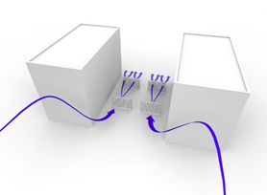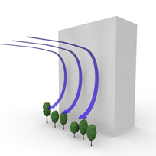
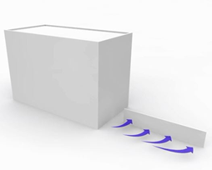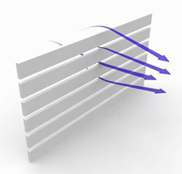
Image 3: Examples of Localized Accessory Elements for Wind Control, Provided by RWDI.
Additional Information Note 1:
If City staff consider the submitted Wind Study to be incomplete, unsatisfactory, inconsistent, insufficient, authored by an unqualified individual, or if it fails to satisfy the requirements set out in this TOR in any other manner, the associated development application may be deemed incomplete and returned to the applicant.
Note 2:
Deeming an application complete does not guarantee that the contents of the study are acceptable to City staff and/or that the application will be approved.
Note 3:
If a request for a Wind Study is not made at an earlier stage in the development process, this does not preclude the City from requesting a Wind Study at a later stage. Once an application has been deemed “complete”, the City may require additional information, reports, and/or studies following a more detailed review to assess the implications of an application for approval.
Note 4:
The City of Cambridge is committed to complying with the Accessibility for Ontarians with Disabilities Act (AODA). In our everyday work with businesses institutions, and community partners we anticipate the same commitment to AODA compliance. Therefore, the Wind Study must be AODA compliant and must meet the current provincial standard for compliance.
Note 5:
The City reserves the right to request an updated study, or an addendum thereto, should staff determine that changes in the development proposal or changes to legislation warrant further/modified planning analysis.
Note 6:
City staff reserve the right to require a peer review of submitted materials by an appropriate agency or qualified professional, the cost of which will be borne by the applicant.
Note 7:
Documents and all related information submitted to the City as part of a complete development application are considered public documents once submitted.
Note 8:
The Wind Study shall be submitted in conjunction with the applicable development application(s), unless otherwise agreed to by the City.
Note 9:
This Terms of Reference document is intended to be used for guideline purposes only, and will be used to provide technical direction throughout the planning and development process. Completion of a report in alignment with the requirements of this Terms of Reference will not guarantee approval of the development application in question.
Note 10:
This TOR is relevant at the time of publishing and will be updated as necessary to reflect current policy, best practices, and accepted standards. It is the applicant’s responsibility to ensure the report is prepared in accordance with the most recent version of the TOR issued by the City.

