Date: 04/21/2026 Internal Memo #: IM26-003IFS
To: Council
Circulated to: Rob Axiak, City Manager; Yogesh Shah, General Manager of Infrastructure Services; Mike Parsons, Director of Environmental Services
Department: Infrastructure Services
Division: Environmental Services
From: Jason Alexander, Manager of Wastewater; David Cattrysse, Utilities Compliance Technologist
Subject: 2025 Stormwater System Performance Report

Comments
RECOMMENDATION(S):
THAT IM26-0003IFS 2025 Stormwater System Performance Report be received for information.
EXECUTIVE SUMMARY:
Purpose
The Purpose of this report is to provide the Ministry of the Environment, Conservation and Parks (MECP), as well as Council, with an annual performance report for the City of Cambridge’s (City’s) Stormwater Management (SWM) System, covering the period of January 1st 2025 to December 31st 2025, in compliance with the City’s Consolidated Linear Infrastructure Environmental Compliance Approval (CLI-ECA). The annual performance report contains summaries and interpretations of monitoring data, environmental trends, action items/corrective actions, maintenance/repairs, customer feedback, system alterations, and spills.
Key Findings
System Overview
- First full calendar year for Stormwater Division
System Description
- The SWM System is worth approximately $1.034 billion
- 37% of the system installed over previous 25 years
- 71% of SWM pipes are concrete, 25% plastic. Over the past 10 years The City has installed 50% concrete pipe and 50% plastic pipe during system growth and rehabilitation.
Monitoring Data & Environmental Trends
- Less rainfall in 2025 compared to 2024. The City’s 5, 10, and 20-year rainfall trending are increasing.
- Less flow in the Grand River in 2025 compared to 2024. The Grand River’s 5, 10, and 20-year flow trends are decreasing
- The City’s Inflow and Infiltration percentage was 14.8% down from 15.2% in 2024. City projects and preventative maintenance have helped decreased Inflow and Infiltration over the previous 10-year span
- The City has partnered with the University of Guelph to implement a SWM Monitoring Plan
Operational Problems and Corrective Actions
- 0 SWM main blocks in 2025
- 39 catch basin cleaning/clearing incidents in 2025
- 4 storm retention pond overflows caused by rain events in 2025
Preventative Maintenance
- The City has CCTV’d 85% of the SWM System
- 2,623 (24.7%) total catch basins were cleaned in 2025 resulting in 366.76 tonnes of debris removed from the SWM System
- 95 storm ponds were inspected in 2025
- All City owned dams were inspected in 2025
Customer Feedback
- 28 storm pond complaints investigated in 2025
- 51 catch basin complaints investigated in 2025
System Alterations
- 6 CLI-ECA applications
- 0 Safe Drinking Water Threats noted
Spills
- 49 spill investigations in 2025, with an estimated cost of $21,079 in City staffing and equipment. Roughly $8,474 (40%) recouped through offending parties.
- 4 sewage overflows in 2025
BACKGROUND:
The City’s CLI-ECA (015-S701) was placed into effect on August 31, 2022. Starting with the 2023 calendar year, the City shall prepare an Annual Performance Report for the MECP by April 30 of each calendar year, which includes a summary of required monitoring data, environmental trends, operational problems/corrective actions, maintenance/repairs, customer feedback, system alterations, and spills. This report is to be made available to the public by no later than June 1 of the calendar year.
The City’s 2025 Stormwater System Performance Report complies with the City’s CLI-ECA requirements.
ANALYSIS:
System Overview
The City of Cambridge SWM System provides drainage services for stormwater runoff within the City’s settlement areas and contributes to the Quaternary Ellis Creek – Speed River and Mill Creek – Grand River Watersheds. The City serves as the Operating Authority (OA) for the system, which is comprised of assets owned and maintained by the City, the Regional Municipality of Waterloo (ROW), and private property owners.
The Stormwater Division of Environmental Services was implemented in late 2024, with its first full year as a division occurring in 2025. The City requires 21.61 Full-Time Equivalents to maintain and operate the SWM. Stormwater duties were previously performed solely by the Wastewater Division
The implementation of the City’s SWM System involves the participation and coordination of numerous public agencies, each of whom have specific mandates, including, but not limited to the MECP, The Ministry of Natural Resources (MNF), The Grand River Conservation Authority (GRCA), and the ROW.
System Description
The City’s SWM System contains approximately 675.6 km of storm sewer leads and mains, connecting 12,676 catch basins, 21 km of culverts, 52 Oil and Grit Separators (OGS), and 135 SWM System ponds, wetlands, and infiltration galleries worth approximately $1.034 billion.
The following charts identify the overall age and material types currently found in the SWM System. Figure 1 indicates the majority of stormwater pipe in the system was installed after 1970, with over a third (37%) of the system installed within the last 25 years. Figure 2 indicates that concrete pipe (71%) is the predominant pipe material in the SWM System, while plastic pipe (25%) accounts for the majority of the remaining material. Over the past decade the City has shifted towards more plastic pipes during SWM system expansion. As a result, system growth and rehabilitation over that timeframe consist of roughly 50% concrete pipe and 50% plastic pipe. Figure 3 indicates that the majority of SWM System pipes have diameters between 300–600 mm (41%). The SWM System primarily consists of standard 300 mm, 375 mm, and 450 mm diameter pipes.
Figure 1 – Storm System Age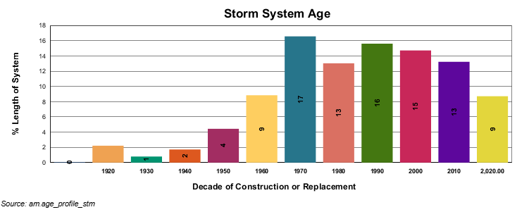

Figure 2 – Storm Pipe Material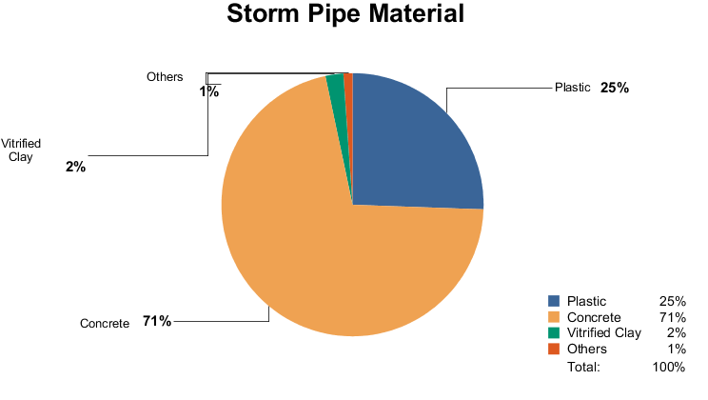
Figure 3 – Storm Pipe Summary By Size
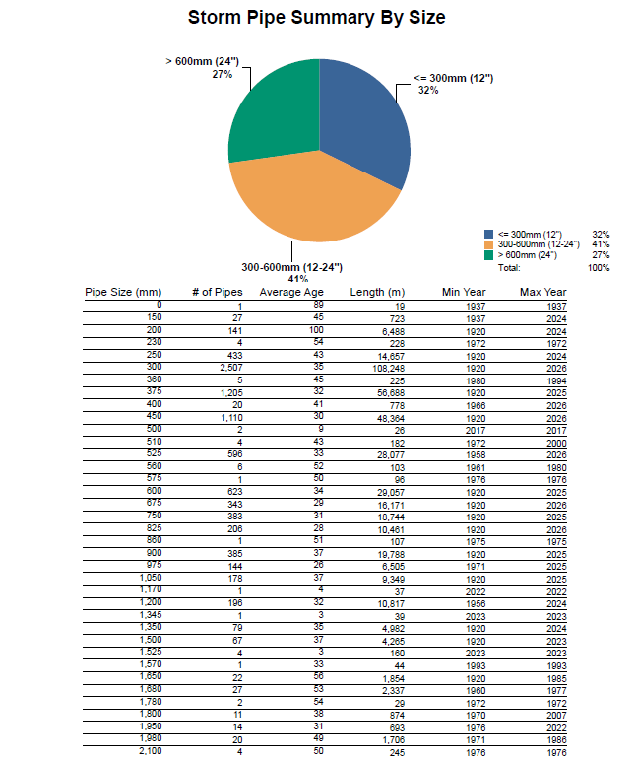
Monitoring Data & Environmental Trends
The climate in Cambridge is a humid continental climate, typical of southwestern Ontario, with mostly moderate winters but the occasional deep freeze. Figure 4 indicates the annual and seasonal temperatures from 2022-2025.
Figure 4 – City of Cambridge Annual & Seasonal Temperatures (2022-2025)
Season | Temp (Cº) | 2022 | 2023 | 2024 | 2025
Annual | Min | -16.1 | -19.8 | -17.4 | -18.5
Annual | Max | 34.0 | 31.7 | 34.0 | 34.0
Annual | Avg | 9.4 | 9.3 | 10.1 | 8.8
Annual | Avg Diff | n/a | -0.1 | 0.8 | -1.3
Spring  (Mar 21 – Jun 20) | Min | 5.4 | -8.1 | -9.4 | -6.2
Spring  (Mar 21 – Jun 20) | Max | 34.0 | 31.2 | 34.0 | 29.4
Spring  (Mar 21 – Jun 20) | Avg | 20.2 | 11.8 | 12.4 | 11.6
Spring  (Mar 21 – Jun 20) | Avg Diff | n/a | -8.4 | 0.6 | -0.8
Summer  (Jun 21 – Sept 20) | Min | -0.1 | -0.2 | 7.0 | 6.9
Summer  (Jun 21 – Sept 20) | Max | 30.6 | 31.7 | 31.6 | 34.0
Summer  (Jun 21 – Sept 20) | Avg | 14.6 | 19.4 | 20.5 | 21.0
Summer  (Jun 21 – Sept 20) | Avg Diff | n/a | 4.8 | 1.1 | 0.5
Autumn  (Sept 21 – Dec 20) | Min | -16.1 | -6.3 | -11.6 | -16.4
Autumn  (Sept 21 – Dec 20) | Max | 11.3 | 28.1 | 28.3 | 27.9
Autumn  (Sept 21 – Dec 20) | Avg | -0.4 | 6.8 | 7.7 | 5.4
Autumn  (Sept 21 – Dec 20) | Avg Diff | n/a | 7.2 | 0.9 | -2.3
Winter  (Dec 21 – Mar 20) | Min | -15.2 | -19.8 | -17.4 | -18.5
Winter  (Dec 21 – Mar 20) | Max | 25.5 | 13.6 | 19.8 | 22.3
Winter  (Dec 21 – Mar 20) | Avg | 3.0 | -0.9 | -0.2 | -2.9
Winter  (Dec 21 – Mar 20) | Avg Diff | n/a | -3.9 | 0.7 | -2.7
Rainfall decreased to 775 mm in 2025 from 950 mm in 2024 as seen in Figure 5. The average yearly rainfall over the previous 5 years (2021-2025) was 852 mm. The City’s 5-year average for rain has plateaued in recent years but has increased over 10-year and 20-year periods.
Figure 5 – Yearly Rainfall (mm) 2016-2025

The City of Cambridge is located within the Quaternary Ellis Creek – Speed River and Mill Creek – Grand River Watersheds. The confluence of the Grand River and the Speed River provide the majority of receiver inflow within the northern boundaries of the City’s settlement area, with a variety of smaller streams and stormwater infrastructure contributing inflow to the Grand River throughout the City. The City’s primary receiver outfall is the Grand River to the south of the City’s settlement area.
The Grand River’s outflow from the City decreased from 38.0 m3/s in 2024 to 33.4 m3/s in 2025, in line with the decrease in rainfall between 2024 and 2025. 5-Year and 10-Year trending show an overall decrease in both inflow and outflow within the City as seen in Figure 6.
Figure 6 – City of Cambridge Surface Water Flows (m³/s)

The City’s 20-year trending shows an increase in annual rainfall contrasting with a decrease in annual outflow as seen in Figure 7. While no direct causation has been determined, similar trending can be caused by climate change factors in humid continental climates such as Southwestern Ontario. The City will continue to monitor these environmental parameters.
Figure 7 – Long-Term Outflow and Rainfall
Inflow & Infiltration (I&I) is groundwater/rainwater which ends up in the Wastewater Collection System, rather than the SWM System. I&I has been estimated to be roughly 2,287,450 m3 (14.8%) in 2025, down from 2,396,213 m3 (15.2%) in 2024. The City continues to prioritize projects and preventative maintenance designed to minimize I&I, which has lead to a steady decrease as seen in Figure 8.
Figure 8 – Inflow & Infiltration (%)

The City’s CLI-ECA requires a SWM System Monitoring Plan which should be put into place within 24 months of the publication of the MECP’s monitoring guidance document. As the monitoring guidance document has not been published at the time of this report, the current regulatory timeline is to be determined. The City formed a partnership with the University of Guelph in 2025 to coordinate a Stormwater Quality Monitoring Program Pilot Project with implementation aimed for 2026. The goal of the City’s Monitoring Plan is to provide data focusing on long-term receiver health, creating a strong foundation for continued environmental stewardship. Data from these monitoring stations will be provided and analyzed in future Performance Reports.
Operational Problems and Corrective Actions:
Environmental Servies defines “Operational Problem” as exceptional circumstance which may directly affect the City’s ability to provide stormwater protection to the public or the environment including, but not limited to, storm main blocks/collapse, catch basin blockages, and storm pond overflows.
Blockages found in storm mains may induce localized flooding which can cause varying degrees of damage to the environment and public property. The City had 0 stormwater main blocks in 2025 and a total of 2 blocks over the previous 5 years. Preventative maintenance practices such as CCTV inspection have helped maintain storm pipe integrity, catching issues that may have caused future stormwater main blocks before they occurred.
Obstructions found in catch basins can re-route stormwater flow which may cause damage to public property, and the introduction of unwanted irritants to the environment. Environmental Services dealt with 39 incidents requiring catch basins to be cleared of external or internal obstructions in 2025, compared to 34 in 2024. Incidents included general debris, biodegradables, and broken infrastructure, and were dealt with in a variety of ways including CCTVing the area, flushing, and confined space entry. The City maintains a catch basin cleaning preventative maintenance program, including weekly inspections, which proactively aims to reduce the amount of obstruction incidents. Additionally, 42 catch basins and manhole covers were repaired, adjusted, or replaced to ensure customer safety in 2025, compared to 69 in 2024.
Runoff from SWM facilities may cause varying degrees of damage to the environment and public property. There were 4 storm retention pond overflows tracked by the City in 2025, compared to 3 in 2024. Heavy rain events caused all 4 of the overflows, with levels returning to normal in a natural manner. Infrastructure Services attended to any debris caused by the overflows on behalf of Environmental Services. The City’s Monitoring Plan will provide additional overflow tracking, allowing for more investigations for future performance reporting.
Preventative Maintenance:
The City has established a preventative maintenance schedule to help reduce operational problems before they occur within the SWM System. Regular preventative maintenance ensures continued functionality, and helps identify and address issues early on, preventing potential failures or blockages that could lead to flooding, erosion, or water quality issues. This proactive approach ensures the system operates effectively, reducing the risk of damage and minimizing the environmental impact.
The integrity of the City’s stormwater infrastructure is an important aspect of the SWM System as the City aims to avoid blockages, leaks, or flooding events which may cause larger operational problems. CCTV technology allows Environmental Services staff to assess pipe integrity, identify potential issues for future works, and observe blockages, without causing disruption to City customers. Environmental Services staff inspected 562 stormwater pipes, or roughly 23.1 km of the City’s SWM System, with CCTV cameras in 2025 compared to 981 pipes (41.2 km) in 2024. Over the past 5 years the City has inspected an average of 704 pipes, covering 30.3 km, annually. The City has now documented 85% of the Stormwater Management System on camera with the help of Environmental Service’s staff.
The City maintains a catch basin cleaning preventative maintenance program which proactively aims to reduce the amount of obstruction incidents. 2,623 (24.7%) total catch basins were cleaned in 2025 resulting in 366.76 tonnes of debris removed from the SWM System, compared to 3,011 (28.3%) catch basins and 326.92 tonnes in 2024. Over the past 5 years the City has cleaned an average of 3,082 (29.0%) catch basins and 330.19 tonnes annually.
As part of the City’s stormwater preventative maintenance schedule, Environmental Services staff perform weekly storm pond inspections. These inspections observe the overall health of storm ponds as Environmental Services staff aim to proactively detect any potential operational problems which may arise. 95 storm ponds were inspected in 2025, down from 139 inspected in 2024. Over the past 4 years the City has inspected an average of 105 ponds annually. The drop in storm pond inspections corelates with the Stormwater Division’s additional focus on stormwater inlet and outlet inspections in 2025. In total 115 (63.2%) stormwater inlets and 545 (58.1%) stormwater outlets were inspected during the division’s first full year.
Oil and Grit Separator (OGS) Units are an important piece of the City’s Stormwater Management System as they are designed to trap and settle large sediments and particulate matter, debris, and hydrocarbons from highly impervious areas. Environmental Services inspected 38 of the 52 City-owned OGS Units in 2025. Down from all 52 in 2024.
The City added biannual dam inspections to its SWM System preventative maintenance schedule. Environmental Services inspected all 3 City-owned dams in 2025, with inspections taking place while deploying and removing seasonal booms.
Customer Feedback:
In addition to operational problems and preventative maintenance, the City investigated 28 storm pond customer complaints ranging from private drainage issues and potential flooding to site access and safety concerns. Environmental Services staff ensured each issue was addressed and customers were informed within an appropriate timeframe.
Environmental Services staff promptly investigated 51 public catch basin complaints ranging from 22 incidents requiring external catch basin clearing, 17 requiring internal catch basin clean outs, 6 spills, and 6 incidents of personal item retrieval.
System Alterations
In 2025 the Stormwater Management System grew by approximately 0.1%, the equivalent of 0.6 km of new storm pipe and leads, with an additional 1.8 km of pipe and leads replaced or rehabilitated, compared to 3.1 km of new infrastructure added and 1.0 km of replacements and rehabilitation in 2024.
The City approved 6 projects through the City’s CLI-ECA process in 2025, which included additions to, or alterations of, the SWM System as seen in Figure 9. Each project was carefully reviewed by Environmental Services staff, as well as the City’s Engineering department, before projects were able to proceed.
Figure 9 – Stormwater Management System Alterations
Reference Number | Project Name | Description | Project Address | Significant Drinking Water Threat
2024-04 | iPort Cambridge | This ECA application is intended to amend the approved ECA to include the SWM corridor/linear pond located to the east of Intermarket Road | 250 Allendale Road | No
2024-09 | Capital Project A-00997-40 – Cooper St Reconstruction | Full reconstruction of Cooper St. including the replacement of existing storm sewers. | Cooper St | No
2025-01 | Model At Main Subdivision | Addition of municipal storm sewers and stormwater management facility within Phase 1 of a new development subdivision. | 840 & 940 Main St E  345 Franklin Blvd | No
2025-02 | River Mill Phase 5 | Storm sewers on Briardean Road (From approximately 70 meters south of Maple Grove Road to approximately the middle of Pointer Street). | 800-875 Briardean Road | No
2025-03 | Capital Project A-00542-30 - Queen St W Reconstruction | The project includes replacement of underground storm sewers and structures along with full road reconstruction. Existing 250mm - 450mm diameter concrete storm sewer and existing maintenance holes and catchbasins to be replaced with new 250mm - 450mm diameter PVC storm sewer along with new maintenance holes and new catchbasins | Queen St. W | No
2025-04 | Upper Green Gate Subdivision | Addition of municipal storm sewers within a new development subdivision. | 1005 Main St East | No

Spills
The City engaged in 49 Environmental Spill investigations in 2025, with an estimated cost of $21,079 in City staffing and equipment, compared to 50 spills costing $26,882 in 2024. Environmental Services was able to locate and invoice culpable parties on 12 spill investigations, recouping roughly $8,474 (40%) of the City’s Spill’s expenditures. The City dealt with a diverse range of spills including various oil/gas-based substances, soap-based chemicals, and both public and private sewage overflows. A list of 2025 sewage overflow, providing Spills Action Centre (SAC) reference numbers, can be seen in Figure 10.
Figure 10 – 2025 Sewage Overflows
# | Date | Location | Description of Spill Event | Actions Taken
1 | 2025-03-02 | 200 Franklin St | SAC: 1-132FER  Volume: <100 L  A sanitary main block in a parking lot surcharged sewage into adjacent stormwater infrastructure. | The City hydrovaced the effected maintenance hole to relieve the block.  The adjacent stormwater infrastructure and surface level discharge was hydrovaced, clearing all sewage from the affected areas.
2 | 2025-03-12 | 166 Grand Ridge Dr | SAC: 1-IT9LD1  Volume: Unknown  A sanitary main block surcharged into an adjacent catch basin. | The City hydrovaced the effected maintenance hole to relieve the block.  The adjacent stormwater infrastructure and surface level discharge was hydrovaced, clearing all sewage from the affected areas.
3 | 2025-03-25 | 1535 Bishop St N | SAC: 1-MSD1PB  Volume: ~1000L  Sewage leaked out of a Vactor Truck onto a concrete surface. | The City hydrovaced the affected area. No sewage entered stormwater infrastructure during the event.
4 | 2025-10-02 | 1010 Elgin St N | SAC: 1-PLGGMQ  Volume: ~ 1 year’s worth of public washroom usage  A sanitary line from a business was tied into stormwater infrastructure during a recent renovation of the business. | The City flushed the affected stormwater infrastructure and cleaned the affected storm pond outfall.  The City has told the offending business to suspended operations and not run any water on site until the issue has been resolved internally.

EXISTING POLICY / BY-LAW(S):
City of Cambridge Wastewater Quality Management System Policy
As the owners and operators of the City of Cambridge’s wastewater collection system we are committed to:
- Providing stormwater protection to the public
- Mitigating the impact of stormwater on the environment
- Maintaining and continually improving the SWM System

FINANCIAL IMPACT:
The 2025 Stormwater Management budget was $8,568,00, up from $7,577,400 in 2024. The budget is projected to be $8,235,700 in 2026.

Attachments
N/A
Approvals:
☒ Manager/Supervisor ☒ General Manager ☐ City Manager

