
MyWater Account Guide – Step by Step

1. Go to the following link: https://www.cambridge.ca/en/your-city/Water-Account.aspx

2. Click Sign up for MyWater Portal
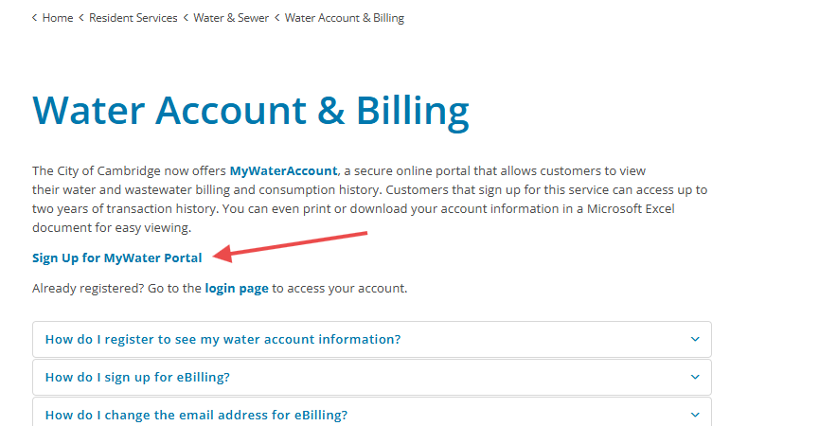

3. Accept the disclaimer

4. Enter the Required information- your Account number can be found at the top of your water bill
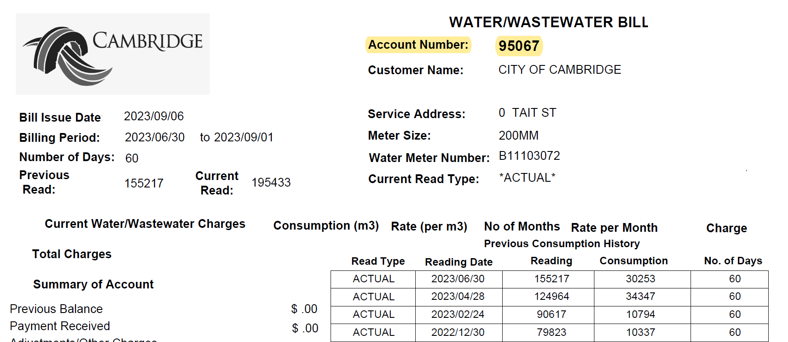

5. Click next, then submit
6. Login to your new MyWater account
7. Click “Go to Connect Portal” to get water usage data broken down
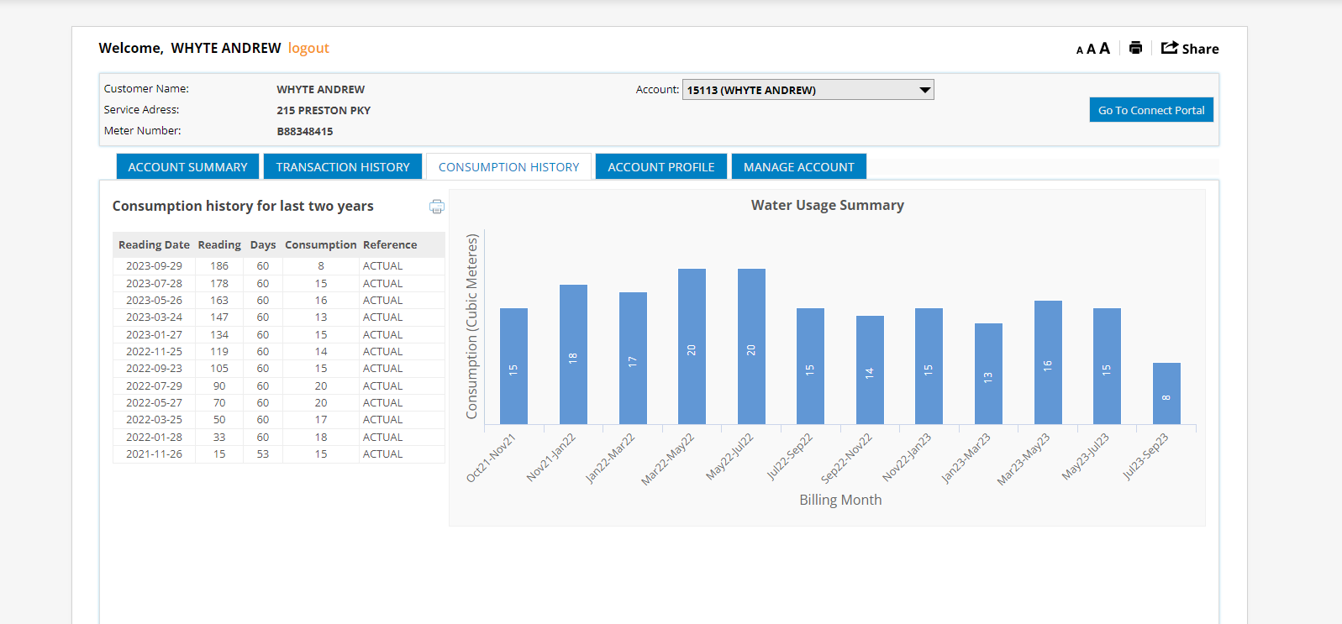

8. In the My Progress window, click on the Current usage bar to view daily usage
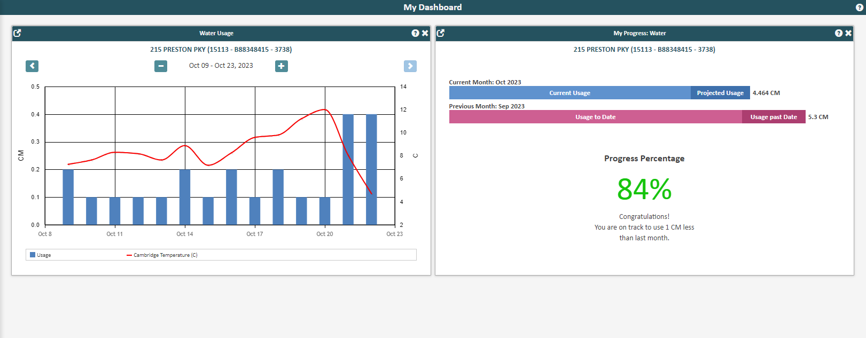

9. To set alarm thresholds
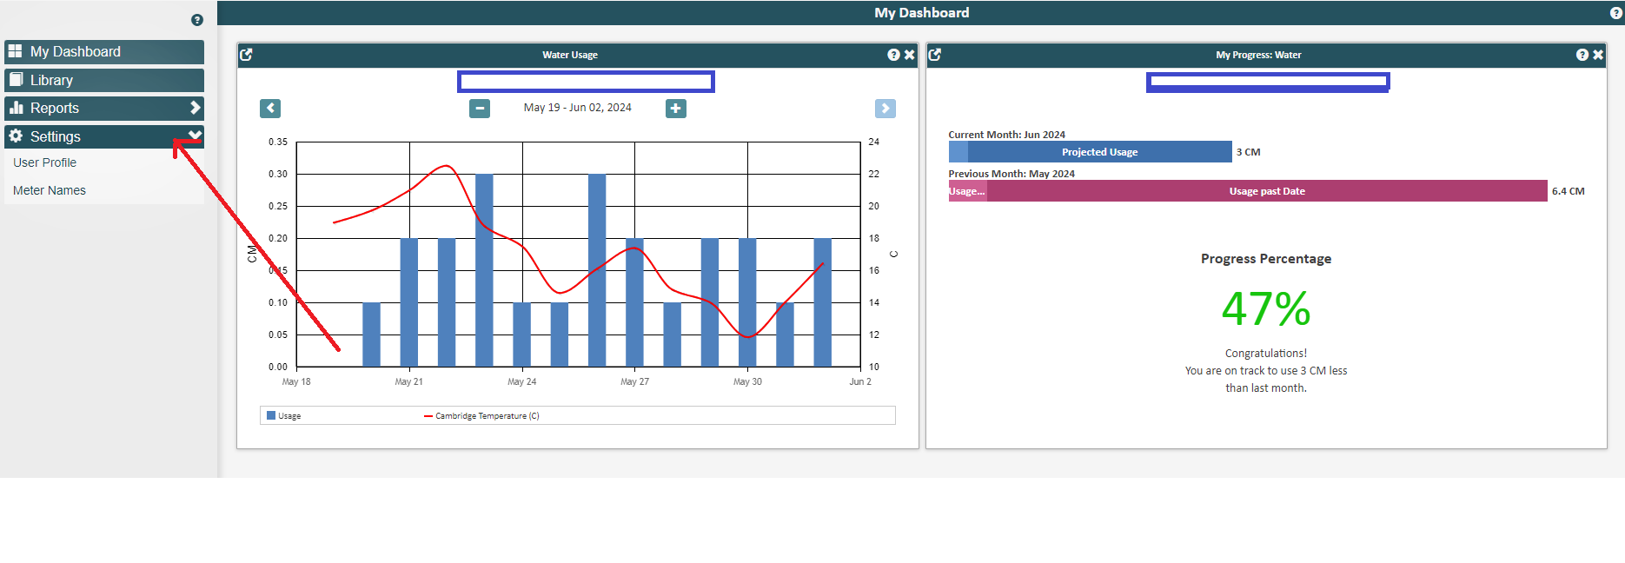Click Settings
User Profile
Click add email and input email you would like notifications sent to
Under notifications click add notification
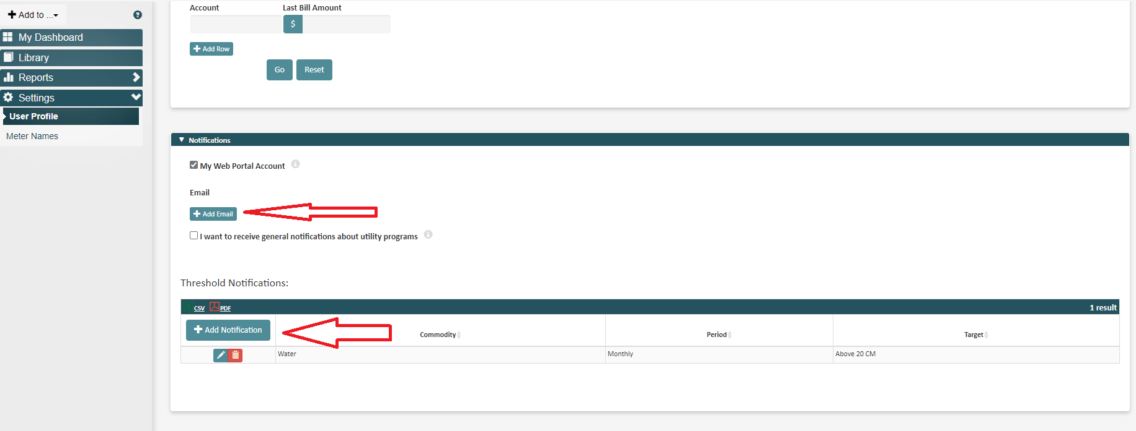
Set alarm threshold
